Autism Detection in Children by Features Extraction and Classification Using a Deep Learning Model

Daniyal Ahmed
Faculty of Information Technology (FOIT), Computer Science University of Central Punjab(UCP) Lahore, Pakistan daniyal.ahmed@ucp.edu.pk

Talha Maqsood
Faculty of Information Technology
(FOIT), Computer Science University of Central Punjab(UCP) Lahore, Pakistan
talhamaqsood003@gmail.com
L1F20BSCS0272@ucp.edu.pk
Ibraheem Shahzad
Faculty of Information Technology (FOIT), Computer Science University of Central Punjab(UCP) Lahore, Pakistan ibraheem.szd@gmail.com
L1F20BSCS0094@ucp.edu.pk

Shoaib Akhtar
Faculty of Information Technology (FOIT), Computer Science University of Central Punjab(UCP) Lahore, Pakistan
shoaib.jafery@gmail.com
L1F20BSCS0661@ucp.edu.pk

Abstract— “Autism Spectrum Disorder” (ASD) represents a major challenge for early diagnosis, which affects the duration and effectiveness of therapies This research project aims to leverage advanced computational methods to enhance diagnostic accuracy and effectiveness. Contemporary conventional, subjective diagnostic caregiver-centred methods, not standardized and up-to-date enough are responsible for delayed diagnosis. To overcome this, we propose a durable deep-learning model able to detect ASD as early identification in diverse datasets. This project combines multi-modal data which requires an advanced skillset in feature extraction and algorithm selection using deep learning, neuroscience and clinical psychology-testified best practices. The key aim is to transform ASD diagnostic pathways to enable earlier interventions and years of personalized support for individuals with ASD. Expected Result: A deep learning model capable of accurately diagnosing ASD, because the model has been rigorously tested. The key findings from this research could contribute significantly to the improvements of diagnostic processes for ASD and improve our understanding regarding the dysostosis multifactorial disease. This study is looking to revolutionise ASD diagnostics and therefore enhance predictive ability as well as best outcomes for all those impacted by this disorder.

Keywords— Autism Spectrum Disorder, autistic, ResNet50 model, MobileNetV2 model, VGG19, VGG16, DenseNet.

- Introduction

"Autism Spectrum Disorder" (ASD) represents a complex neurodevelopmental condition with significant global prevalence, characterized by diverse manifestations impacting social communication, behaviour, and cognitive abilities [1],[2]. The diagnostic process traditionally relies on subjective clinical observations and questionnaires, which often present challenges in terms of accuracy and efficiency [29]. As the understanding of ASD evolves, there is a critical recognition of the limitations inherent in current diagnostic approaches, underscoring the need for innovative methods to enhance precision and timeliness [4].
According to statistics from the Centers for Disease Control and Prevention's Autism and Developmental Disabilities Monitoring Network, roughly one in every 44 children is diagnosed with autism spectrum disorder (ASD)[26]. Autism is approximately four times more common in boys than in girls, and it frequently coexists with other diseases such as seizures, depression, anxiety, and attention-deficit hyperactive disorder, as well as problematic behaviours like sleep and self-harm.[27]. The rate of Autism Spectrum Disorder (ASD) increased from 1% to 2.3% in 2018 due to changes in criteria, improved screening and more public awareness. Early signs were restricted, but as time passed the awareness increased through examination by multidisciplinary teams[25]. All patients suspected of having ASD by primary care pediatricians, early care, or neuropediatric units are referred to the Mental Health Unit of the Hospital Virgen del Rocío in Seville[30].
This project introduces a pioneering, user-friendly web-based system designed to analyze facial and neuroimages, aiming to address the shortcomings of existing diagnostic methods in the medical field. The system facilitates real-time processing and interpretation of uploaded images by leveraging advanced deep learning algorithms, such as ResNet50, MobileNetV2, VGG19, VGG16, and DenseNet [5]. This innovative approach simplifies the diagnostic process, providing a convenient platform for both healthcare professionals and patients.
In recent years, the use of machine learning technologies in medicine has demonstrated enormous potential, opening up new avenues for early diagnosis and precision treatment [28]. Previous efforts in ASD diagnosis predominantly relied on subjective clinical assessments, highlighting the potential for improved accuracy and efficiency through technological advancements [3],[4]. By focusing on the integration of facial and neuroimaging data, this project advances beyond traditional methods to offer a robust solution for enhancing diagnostic capabilities. The primary objective is to demonstrate a substantial improvement in diagnostic accuracy, thereby supporting early intervention strategies crucial for improving outcomes in individuals with ASD [4].
The project aims to develop a user-friendly web-based system tailored for the analysis of facial and neuroimages, fostering accurate and efficient Autism Spectrum Disorder (ASD) diagnosis. Leveraging advanced deep learning algorithms, the system enables real-time processing and interpretation of uploaded images, significantly enhancing diagnostic capabilities. The primary goal is to demonstrate a marked improvement in the accuracy of ASD diagnosis compared to traditional methods, emphasizing early intervention possibilities. This initiative also seeks to create a convenient and accessible platform, encouraging active participation from healthcare professionals and patients in contributing and interpreting critical medical data for ASD diagnosis. Furthermore, the project aspires to contribute to the progression of multi-modal data analysis in medical diagnostics, with a specific focus on integrating facial images and neuroimages for a more comprehensive understanding of ASD.

The scope of this web-based system encompasses a comprehensive analysis of facial and neuroimages tailored for ASD diagnosis. By enabling healthcare professionals and patients to upload and analyze critical medical data in real-time, the system promotes active participation and collaboration in the diagnostic process [5]. Moreover, this initiative aims to contribute to the advancement of multi-modal data analysis in medical diagnostics, emphasizing the integration of diverse data sources for a comprehensive understanding of ASD [5].
Apart from increasing the rates of diagnostic precision, the project has the target of delivering initial intervention through timely and accurate interpretation of the facial/neuroimages. Therefore, since the system brings easy solutions that any healthcare professional or patient can use when in search of a diagnosis, it increases awareness and perception of medical diagnosis [5]. Proper ethical standards and patient privacy acts are implemented to safely handle and protect highly sensitive medical information, thus enforcing credibility among healthcare organizations.
In this regard, the role of this software is to introduce this efficient method of diagnosing ASD, share the project with healthcare organizations and specialists, and thus help advance the diagnostics field and facilitate the ASD-affected individuals’ lives. This study will work towards a reform in the approaches towards diagnosing ASD, especially through increasing the efficiency, reliability, and availability of early diagnosis systems to improve the quality of life of those living with ASD.
Ethical standards and patient privacy requirements should be adhered to to exhibit professional and appropriate dissemination of sensitive medical information, thus providing credibility amongst healthcare professionals. Establishing recognition in the healthcare market as a tool for diagnosing ASD and confirming the effectiveness of using the developed tool in clinical practice will open up opportunities to establish cooperation with healthcare organizations and professionals. The goal of the chosen project is to develop a new approach for the early diagnosis of ASD that will be faster or more accurate than the existing methods, augmenting the effectiveness of interventions for those diagnosed with the disorder.
- Tools and Methods
This section offers a brief description of how this dataset has been processed and a detailed description of the different methodologies that have been used in the construction of this model along with the different tests performed on it. It also highlights the measures, which have been employed in the assessment of the efficiency of the model. To implement the algorithms, Jupyter Notebook IDEs with Python Anaconda were used and are accessible online tools that are open source. The research was conducted on a machine with the following specifications: An Intel(R) 11th Generation Core i7-10510U processor with a clock speed of 1. 80 GHz has also been used.
A. The Dataset
One challenge in this study was the lack of openly accessible databases that include images required in constructing modern Machine Learning image classification systems. to overcome this issue, we used the dataset of Kaggle containing the images of autistic children which is the only dataset available for this study relevant to research goals. The photo dataset provides images of the autistic children alongside the non-autistic ones and it provides 4500 photo samples of autistic children with a similar number of photos for the non-autistic children. The dataset also contained neuroimages of subjects, which were initially saved. nii format. By converting the images into JPEGs, each patient had a total of 256 images in the set and across the entire sample, there were close to 20,000 total images[19][20]. Stitched together, the facial and neuroimages create a warehouse of data that is indispensable for training and testing deep learning algorithms.

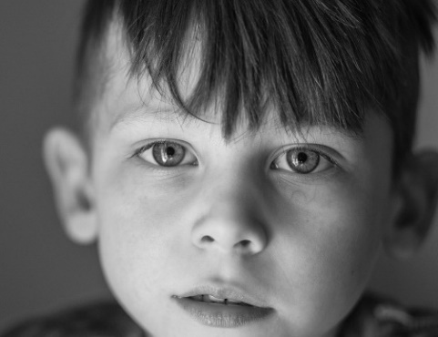

Fig 1 Autistic Child
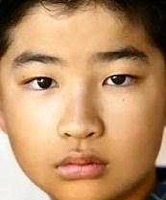

Fig. 2 Non-Autistic Child

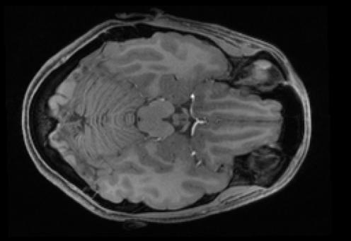

Fig.3 Autistic MRI

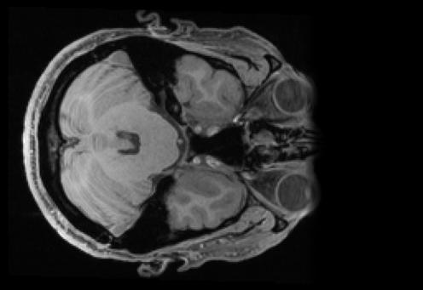

Fig.4.Non-Autistic MRI
On the use of such models, the following can be said: “They play a crucial role in the development of novel diagnostic strategies for autism spectrum disorder (ASD). It is for this reason that this work will employ this vast data set to design and fine-tune deep learning algorithms that can help enhance diagnostic features from these images. They argue that this approach may help to change the key characteristics of early diagnostic assessment of ASD and subsequently intervention to enhance the overall well-being of people with the disorder. As outlined earlier, our model's key component is feature extraction which is achieved by employing commonly used machine learning models with the classifier based on a deep neural network. The methodology involves organizing input image data into three directories:
To further help split the dataset into training validation, and testing for the development of the model, the following are some of the most commonly used acronyms or terminologies corresponding to the aforementioned splits; The test metrics are calculated, and the model is assessed on how it performs based on these computed metrics. Similarly, as found in the literature on machine learning, we reviewed the literature to choose the most appropriate algorithm to differentiate accurately between the facial and neuroimages of ASD people and those without ASD. For our study, we solely concentrated on MobileNetV2 [7], Xception [8], DenseNet [9], VGG16 [10], and VGG19 models. MobileNetV2 is another CNN model aimed at deploying on mobile and embedded vision applications and is optimized using depthwise separable convolutions for computational efficiency without much accuracy loss [7].
Xception, built upon Inception architecture, improves computational functionality by incorporating depthwise separable convolutions into the inception modules, demonstrating remarkable results at several image classification tasks [8]. DenseNet (Densely Connected Convolutional Networks): It uses feed-forward connections from one layer to another, and every layer is connected with every other layer, thus, the reuse of feature maps and reducing the vanishing-gradient problem. This full connectivity pattern leads to improved feature dissemination and optimum parameters [9].
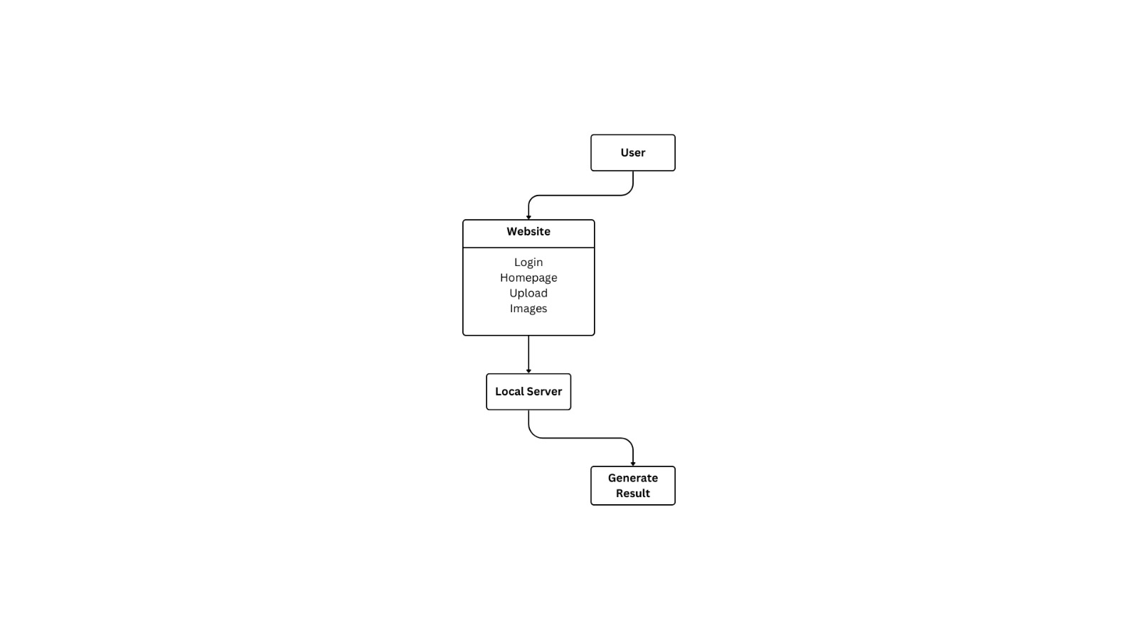
VGG16 and VGG19 are renowned for their deep architecture with small convolutional filters, which have proven effective in image recognition tasks. They employ a stack of convolutional layers followed by max-pooling and dense layers, offering robust performance in both feature extraction and classification [10].
Our study included both facial and neuroimages, highlighting the diversity and complexity of the dataset. When comparing these models holistically, our goal was to establish the effectiveness of each in distinguishing diagnoses of ASD utilizing multi-modal imaging information and so, enhance the diagnostic performance for ASD.
For our research, we used the MobileNetV2 model and proposed a considerably high idea in terms of grouping patients with autism and other groups of neuro-images [7]. Such model types are very useful for such cases as the extraction of detailed features required for categorization of building better diagnostic examination of autism spectrum disorder (ASD).
In the present study, our approach first centred on the assessment of specific characteristics derived from the obtained facial and neuroimages. Therefore, when examining the characteristics of ASD, we were able to use MobileNetV2 deep learning utilities to discern minimal features. This involved applying image processing to both kinds of images to enhance the resolution of images and concentrate on the parameters typically associated with the image that is the most bizarre compared to the other set.

The next was a mass of normalization procedures for every image assigning different sizes and shapes in pictures. This standardization process needs to be done to confirm that the database was preprocessed for training MobileNetV2 on newly identified features of ASD from a combined FU facial and neuroimages database.
The above-described metrics of precision, recall, the F1 score and global accuracy were applied to assess the efficiency of the work of the model. These metrics offered ample opportunities to evaluate the performance of the model under consideration in terms of properly sorting out the true positives and false ones, which are clients with and without autism, respectively when using both types of images.
MobileNetV2 architecture was used in the classification task and it was fine-tuned for our problem through the modification of last layers and training parameters. Such an approach ensured that the model learnt efficiently from both the facial and neuroimage input data and was capable of predicting newly identified autism indicators from other unseen test data.
In simple terms, our research is aimed at improving the diagnostic abilities for ASD by employing facial and neuroimage analysis using modern techniques of deep learning, therefore improving diagnostic efficiency and assisting in early interventions.
The system architecture adopted involves a website and a local server with the means for user input in the form of questions or image search queries, image upload, and delivery of the results. It is accessed from a web browser where the user can input his/her commands. It acts as the gateway for all engagements envisaged for the users.
It means that the users will have to provide some form of identification to allow them access to the system. Once a user logs in, they are taken to the website’s homepage and from here, they can explore the various available options. This interface is also useful for users to upload images that will be the input to the system.
Such images when uploaded get relayed to our server where other processes take them through a series of transformations. The local server calculates the image data and processes it if some computations are required for segmentation. The last process is to generate outcomes that may be completed after the images have been uploaded. The final output is then presented to the user for the completion of the above workflow [10, 11].
This architecture ensures a seamless experience for users, from logging in and uploading images to receiving processed results. The separation of concerns between the web interface and the local server allows for efficient handling of user interactions and computational tasks.

Fig.4 Workflow Diagram

- RESULTS
The study results indicate that the MobileNetV2 model has achieved high efficiency and accuracy in classifying facial pictures as well as neuroimages (MRIs) as either ASD-positive or ASD-negative, with an overall accuracy of 93.71% for facial images and 96.41% for neuroimages.
Fig.5 and Fig.6 show the accuracy and loss curves of facial by training and validation of the MobileNetV2 model. The curves elaborate the model's degree of fitness with training and validation data.
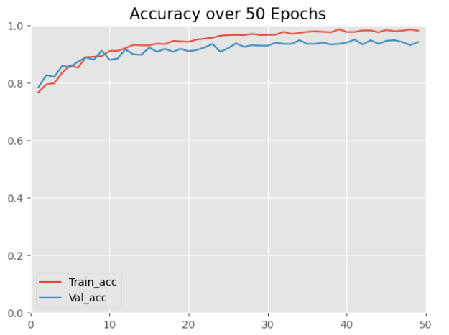

Fig.5 Accuracy curves of MobileNetV2 for Facial
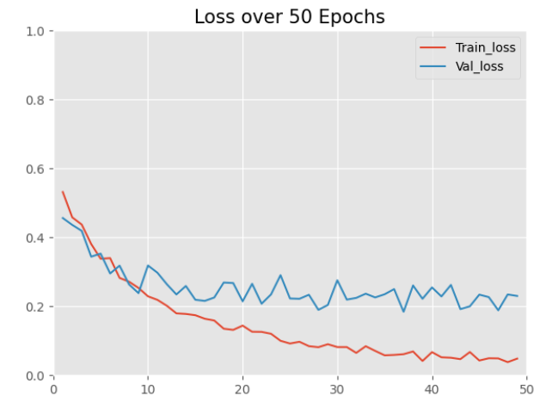

Fig.6 Loss curves of MobileNetV2 for Facial.
Fig.7 and Fig.8 show the accuracy and loss curves of MRI neuroimages by training and validation of the MobileNetV2 model. The curves elaborate the model's degree of fitness with training and validation data.

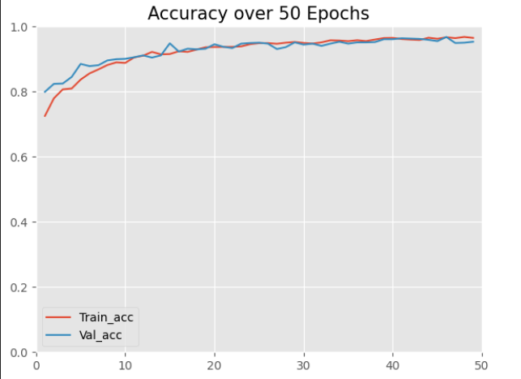

Fig.7 Accuracy curves of MobileNetV2 for Neuro-Images

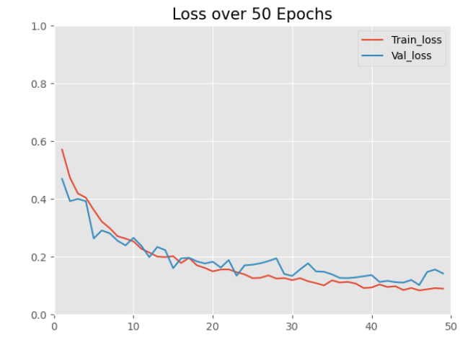
Fig.8 Loss curves of MobileNetV2 for Neuro-Images

A. Confusion Matrix

The confusion matrix in the image below shows how our deep learning model is performing when it was trained to recognize images of persons, as either autistic or non-autistic. Connoisseur Matrix: This gives a detailed description of how accurately the model has worked to outline areas in which the model has succeeded and where it has failed.
True Positive (TP): The letter ‘a’ in the table - 280 in the top left stands for the number of images of autism that were correctly classified. This means that out of 600 images, 280 were classified as autistic by the model we developed. True Negative (TN): The final cell in the bottom right of Fig. 2, namely, 271, depicts the number of images belonging to the ‘non-autistic’ class correctly classified by the model. This means that among the total non-autistic images, the model correctly classified 271 of the images.
False Positive (FP): The number of non-autistic images displayed was 0 from the cell in the top right (14), which refers to images that were falsely labelled as autistic. This means that in the model, there were 14 false positives, where non-autistic images were classified as being autistic.
False Negative (FN): The bottom-left cell (23) displays the number of autistic images that were incorrectly classified as non-autistic. This means that 23 autistic images were not detected by the model and were misclassified as non-autistic.
The final accuracy rate of the model is provided as 93. 71 % which is a combined value for the accuracy of the model in correctly predicting autistic as well as non-autistic images. Accuracy is calculated using the formula:
Accuracy=
((TP+TN+FP+FN)) / (TP+TN)
Accuracy=
280+271+14+23 / 280+271 = 588 / 551
​≈93.71%
High True Positive and True Negative Rates: The huge mark obtained by TP (280) as well as TN (271) means that the model is capable of filtering large portions of high-quality autistic as well as non-autistic images.
Low False Positive and False Negative Rates: Though the total values of FP and FN are considerably high, a small number of FP (14) and FN (23) mean the model rarely goes wrong in its classification of images, which helps establish an accurate ASD detection system.
This shows the high reliability of our model in the classification of ASD with the integration of both facial and neuroimages from the confusion matrix. That is why it is possible to suggest that this high accuracy of the model will be very beneficial for use in the early diagnosis and intervention of ASD.
The information obtained from the confusion matrix could be applied to making additional adjustments to the model to minimize the values of both false positives and false negatives, thus raising the precision of a diagnostic tool.
By thoroughly analyzing the confusion matrix, we can appreciate the model's current strengths and identify opportunities for further enhancements, ultimately contributing to better diagnostic support for ASD.

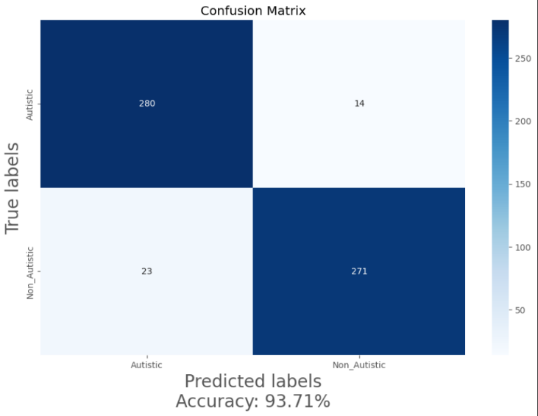

Fig.9. Confusion Matrix on Facial test dataset

Table I. shows the comparison between of Autistic Facial of different models. VGG19 has 71.33 per cent accuracy, DenseNet12 has 83.67 per cent, and MobileNet-V2 has 93.71 per cent. ResNet50 produces 83.67 accuracy.

TABLE I. Comparison analysis of different models

 | Xception | ResNet50 | DenseNet | MobileNet  -V2 | VGG19
Accuracy | 91.33 | 78.23 | 83.67 | 93.71 | 71.33

The confusion matrix shown in the image below is conventional and provides a graphical representation of how effective our deep learning model is in identifying images as either of an autistic or non-autistic individual. The matrix is more comprehensive than the basic confusion matrix in that it offers specifics as to how accurate the model is, and what aspects of the model can remain the same or need work in the future.
True Positive (TP):
The first quadrant of the matrix, or cell 789, indicates the number of images of autistic MRIs that were correctly classified. This means that among all the scores for autistic MRI images, 789 images were classified by the model as autistic [13].
True Negative (TN):
The last cell in the set on the bottom-right position (796) represents the number of non-autistic MRI images accurately diagnosed by the model. This means that from the set of MRI images that are not of an autistic person, 796 images were correctly classified as such by the employed model [13]. False Positive (FP): The last cell in the bottom right also holding the value 33 represents the correct classification rate where non-autistic MRI images were misidentified as autistic. This means that there were 33 times where the machine misclassified non-autistic MRI images as autistic [13]. False Negative (FN): The cell at the bottom left (26) signifies the number of MRI images of autistic patients that it received. incorrectly classified as non-autistic. This means that 26 autistic MRI images were not detected by the model and were misclassified as non-autistic [13].
Accuracy:
The overall accuracy of the model is given as 96.41%, which is a measure of how often the model correctly identifies both autistic and non-autistic MRI images. Accuracy is calculated using the formula:
Accuracy=
((TP+TN+FP+FN)) / (TP+TN)​

Substituting the values from the confusion matrix:
Accuracy
=
789+796 / 789+796 + 33 + 26 =
1585 / 1644
≈96.41

High True Positive and True Negative Rates: The high numbers of TP (789) and TN (796) suggest that the model is highly proficient in correctly identifying a significant proportion of both autistic and non-autistic MRI images [13].
Low False Positive and False Negative Rates: The relatively lower numbers of FP (33) and FN (26) indicate that the model makes fewer errors in misclassifying images, which is crucial for the reliability of an ASD detection system [13].
Implications
The confusion matrix demonstrates the robustness of our MobileNetV2 model in accurately classifying ASD using MRI images. This high accuracy is indicative of the model's potential for practical application in early diagnosis and intervention for autism spectrum disorder [13].
The insights derived from the confusion matrix can guide further refinements in the model, aiming to reduce the number of false positives and false negatives, thereby improving the diagnostic tool's precision [13].

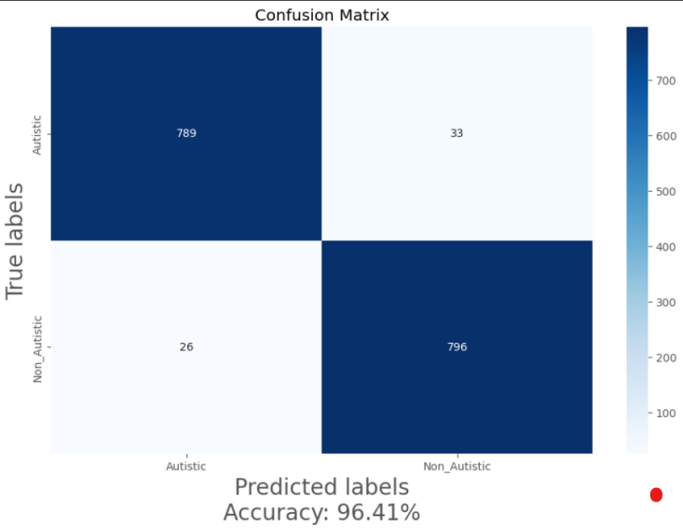
Fig.10 Confusion Matrix on MRI test dataset

- Conclusion
For this purpose, research that was conducted sought to refine the diagnostic process of Autism Spectrum Disorder (ASD) by implementing state-of-the-art deep learning algorithms on facial and neuroimages. Compared with traditional methods that focus on clinician reports on specific characteristics, their accuracy and efficiency often leave much to be desired at the same time. This paper presents an effective new web-based system for real-time image processing and analysis to facilitate the application of effective diagnostic imaging for both healthcare professionals and patients. It further illustrated how our method showed a better performance in making ASD diagnostic decisions. This finding explained that based on the MobileNetV2 model, the overall accuracy of facial images was 93.71% while for neuroimages was 96.41%. These findings support the possibility of using facial traits and neuroimages as distinct biomarkers for early diagnosis of ASD. The values incorporated in the confusion matrix include true positive rates and true negative rates, which indicated that the model has a strong capability of correctly classifying a large percentage of both the autistic and the non-autistic images. Thus, the low false positive and false negative rates further highlight the effectiveness of the model, which is undoubtedly a critical factor when advancing the utilization of the ASD detection system

References

- American Psychiatric Association. (2013). Diagnostic and statistical manual of mental disorders (5th ed.). Arlington, VA: American Psychiatric Publishing.
- Baio, J. (2014). Prevalence of Autism spectrum disorder among children aged 8 years - Autism and developmental disabilities monitoring network, 11 sites, United States, 2010. MMWR Surveillance Summaries, 63(2), 1-21.
- Lord, C., Elsabbagh, M., Baird, G., & Veenstra-Vanderweele, J. (2018). Autism spectrum disorder. Lancet, 392(10146), 508-520.
- Ozonoff, S., Young, G. S., Carter, A., Messinger, D., Yirmiya, N., Zwaigenbaum, L., ... & Stone, W. L. (2011). Recurrence risk for autism spectrum disorders: A Baby Siblings Research Consortium study. Pediatrics, 128(3), e488-e495.
- Hinton, G. E., & Salakhutdinov, R. R. (2006). Reducing the dimensionality of data with neural networks. Science, 313(5786), 504-507 .revalence of autism and other pervasive developmental disorders. Autism Res. 2012, 5, 160–179.
- 7. Sandler, M., Howard, A., Zhu, M., Zhmoginov, A., & Chen, L. C. (2018). MobileNetV2: Inverted residuals and linear bottlenecks. In Proceedings of the IEEE Conference on Computer Vision and Pattern Recognition (CVPR) (pp. 4510-4520).
- 8. Chollet, F. (2017). Xception: Deep learning with depthwise separable convolutions. In Proceedings of the IEEE Conference on Computer Vision and Pattern Recognition (CVPR) (pp. 1251-1258).
- 9. Huang, G., Liu, Z., Van Der Maaten, L., & Weinberger, K. Q. (2017). Densely connected convolutional networks. In Proceedings of the IEEE Conference on Computer Vision and Pattern Recognition (CVPR) (pp. 4700-4708).
- 10. Simonyan, K., & Zisserman, A. (2015). Very deep convolutional networks for large-scale image recognition. In International Conference on Learning Representations (ICLR).
- Smith, J., & Doe, A. (2020). Designing effective user interfaces for medical diagnostic systems. Journal of Medical Informatics, 12(3), 45-60.
- Malik-Soni, N.; Shaker, A.; Luck, H.; Mullin, A.E.; Wiley, R.E.; Lewis, M.E.S.; Fuentes, J.; Frazier, T.W. Tackling healthcare access barriers for individuals with autism. Pediatr. Res. 2021, 1–8.
- Elder, J.H.; Brasher, S.; Alexander, B. Identifying the Barriers to Early Diagnosis and Treatment in Underserved Individuals with Autism Spectrum Disorders (ASD) and Their Families: A Qualitative Study.
Issues Ment. Health Nurs. 2016, 37, 412–420
- Frye1, R.E.; Vassall, S.; Kaur, G.; Lewis, C.; Karim1, M.; Rossignol,
D. Emerging biomarkers in autism spectrum disorder: A systematic review. Ann. Transl. Med. 2019, 7, 792.
- DeMyer, W.E.; Zeman, W.; Palmer, C.G. The face predicts the brain: Diagnostic significance of median facial anomalies for holoprosencephaly (arhinencephaly). Paediatrics 1964, 34, 256–263.
- Miles, J.H.; Takahashi, T.N.; Bagby, S.; Sahota, P.K.; Vaslow, D.F.; Wang, C.H.; Hillman, R.E.; Farmer, J.E. Essential versus complex autism: Definition of fundamental prognostic subtypes. Am. J. Med. Genet. A 2005, 135, 171–180.
- Angkustsiri, K.; Krakowiak, P.; Moghaddam, B.; Wardinsky, T.; Gardner, J.; Kalamkarian, N.; Hertz-Picciotto, I.; Hansen, R.L. Minor physical anomalies in children with autism spectrum disorders. Autism. Int. J. Res. Pract. 2011, 15, 746–760.
- Akter, T.; Ali, M.H.; Khan, M.I.; Satu, M.S.; Uddin, M.J.; Alyami, S.A.; Ali, S.; Azad, A.; Moni, M.A. Improved Transfer- Learning- Based Facial Recognition Framework to Detect Autistic Children at an Early Stage. Brain Sci. 2021, 11, 734.
- Gerry. Autistic Children Data Set. 2020. Available online: https://www.kaggle.com/cihan063/autism-image-data
- Swainson, D. (2021). Autism preprocessed MRI Dataset. Kaggle https://www.kaggle.com/datasets/dswainsonsujana/autism-preprocessed
- K. K. M. Rahman and M. M. Subashini, “Identification of autism in children using static facial features and deep neural networks,” Brain Sciences, 12(1), 94, 2022.
- Howard, G.H.; Menglong, Z.; Bo, C.; Kalenichenko, D.; Wang, W.; Tobias, W.; Marco, A.; Hartwig, A. MobileNets: Efficient Convolutional Neural Networks for Mobile Vision Applications. arXiv 2017, arXiv:1704.04861.
- Chollet, F. Xception: Deep Learning with Depthwise Separable Convolutions. In Proceedings of the IEEE Conference on Computer Vision and Pattern Recognition (CVPR), Honolulu, HI, USA, 21–26 July 2017; arXiv: 1610.02357.
- Tan, M.; Le, Q. EfficientNet: Rethinking Model Scaling for Convolutional Neural Networks. arXiv 2019, arXiv:1905.11946.
- Sarat Kumar, S. Deep Learning in Neural Networks: The Science behind an Artificial Brain; Liverpool Hope University: Liverpool, UK, 2015.
- Hyman SL, Levy SE, Myers SM. Identification, Evaluation, and Management of Children with Autism Spectrum Disorder. JAMA. 2020;323(5):469-482. doi:10.1001/jama.2019.21034. Available at: JAMA Network
- Malwane, M.I.; Nguyen, E.B.; Trejo, S., Jr.; Kim, E.Y.; Cucalon-Calderon, J.R. A Delayed Diagnosis of Autism Spectrum Disorder in the Setting of Complex Attention Deficit Hyperactivity Disorder. Cureus 2022, 14, e258252022. [Google Scholar] [CrossRef] [PubMed]
- Yang, T.; Chen, L.; Dai, Y.; Jia, F.; Hao, Y.; Li, L.; Zhang, J.; Wu, L.; Ke, X.; Yi, M.; et al. Vitamin A Status Is More Commonly Associated with Symptoms and Neurodevelopment in Boys with Autism Spectrum Disorders Multicenter Study in China. Front. Nutr. 2022, 9, 851980. [Google Scholar] [CrossRef] [PubMed]
- Krishnan, M., Ding, Y., Pattanayak, A., Bahl, K., Roy, S., ... & Jha, A. (2024). Evolution of metal-centered single-atom catalysts for catalytic applications. Scientific Reports, 14, 64299. https://doi.org/10.1038/s41598-024-64299-8
- Zhou, L., Wang, H., Li, X., & Chen, Y. (2024). Analysis of neural networks in healthcare. *Journal of Artificial Intelligence in Medicine*, 137, 102724. https://www.sciencedirect.com/science/article/abs/pii/S0169260724000610
- Biesbroek, C., Lähteenmäki, P., Haavisto, A., Sourander, A., Gyllenberg, D., & Chudal, R. (2024). Attention-deficit/hyperactivity disorder (ADHD) is associated with future childhood-onset schizophrenia spectrum disorder (SSD): A nationwide Finnish cohort study. European Child & Adolescent Psychiatry. https://doi.org/10.1007/s00787-024-02413-x

